Infrastructure Batch Merge Tool Tutorial

This tutorial walks through step-by-step how to use the Batch Merge tool.

1. Before you use the Automated Infrastructure Damage Assessment tool, you need to make sure your infrastructure polyline inputs are in one file for each type (i.e. one file for roads). If you have multiple infrastructure files of the same type that you are interested in looking at, then you need to use the Batch Merge tool.
2. Begin by opening ArcMap.
3. Once ArcMap has loaded, click on the “Catalog” icon in the upper left hand corner of the screen.

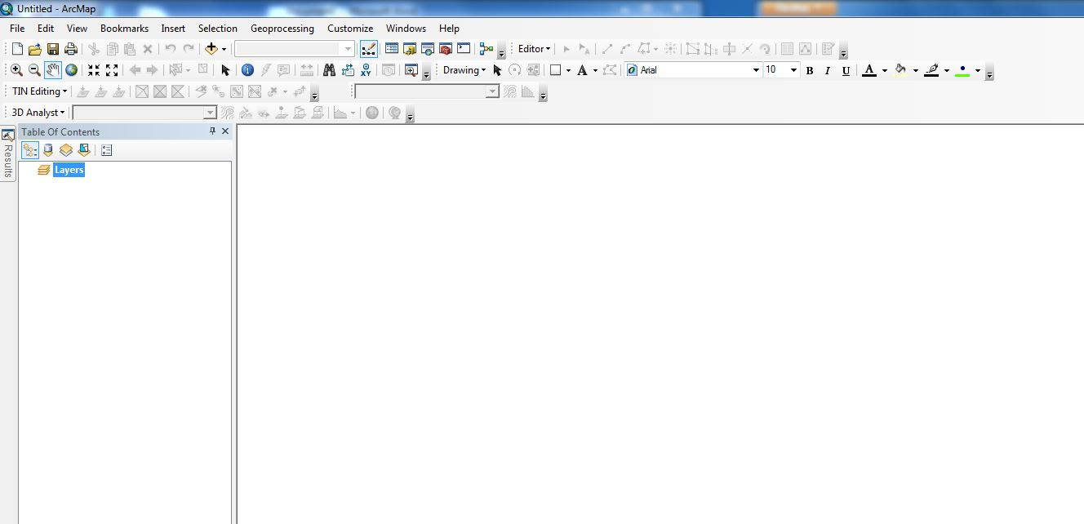

C:\Users\sbarron\Dropbox\JPL - Summer 2013\CA_MS Disasters and Water Resources\Weekly Science Advisor Meetings\Scott's Images\Tutorial_3.JPG

1. Once selected, locate the folder where the Batch Merge tool is located.

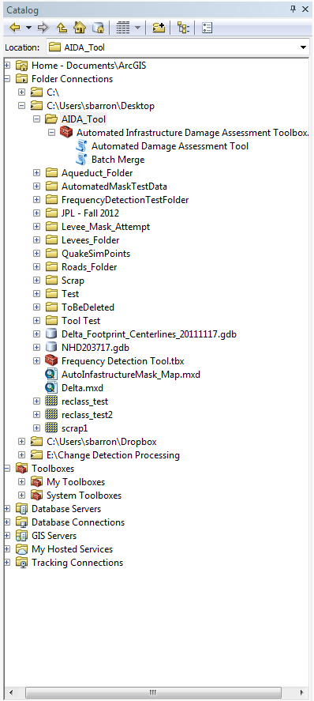

1. Once located, double click on the “Batch Merge” script, located directly under the “Automated Infrastructure Damage Assessment Tool” script.
2. This should bring up the input menu for the tool that will look like this:

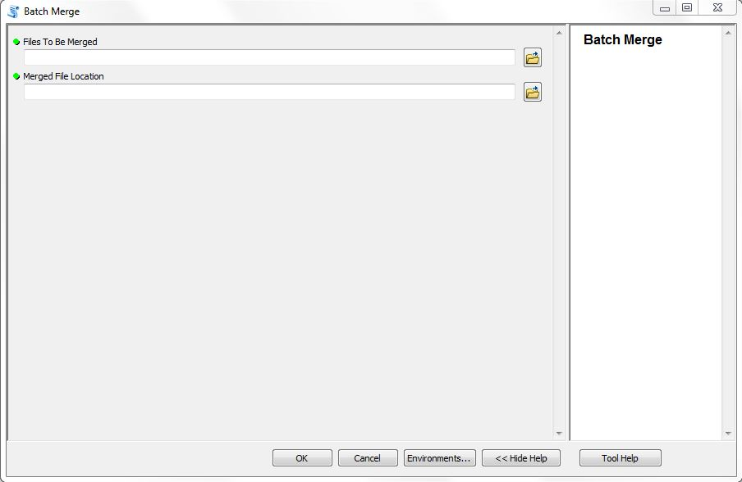

Notice the green dots to the left of the input names. These denote fields that are required by the tool.

1. The first input field is “Files To Be Merged”. This is the folder where the files you want to be merged are located.
2. The second input field is “Merged File Location”. This is the name and location of the merged output file. I would recommend naming it something like “Roads\_Merged.shp” if your input is roads files.

IMPORTANT: Make sure you keep track of where you save this file and its name, as it will become one of the inputs in the AIDA tool later on.

1. Once you are satisfied with your inputs, click the “OK” button and begin the tool.
2. Repeat the process as necessary for other infrastructure files. If you are using the batch merge tool multiple times, it is a good idea to save the outputs to the same folder as this will help when it comes time to set up the AIDA tool.